Abhinav Dinesh Srivatsa

21BDS0340

Information Security Management

Assignment – II

**Aim**

To configure IPS for dynamically connected PCs on a network.

**Layout**

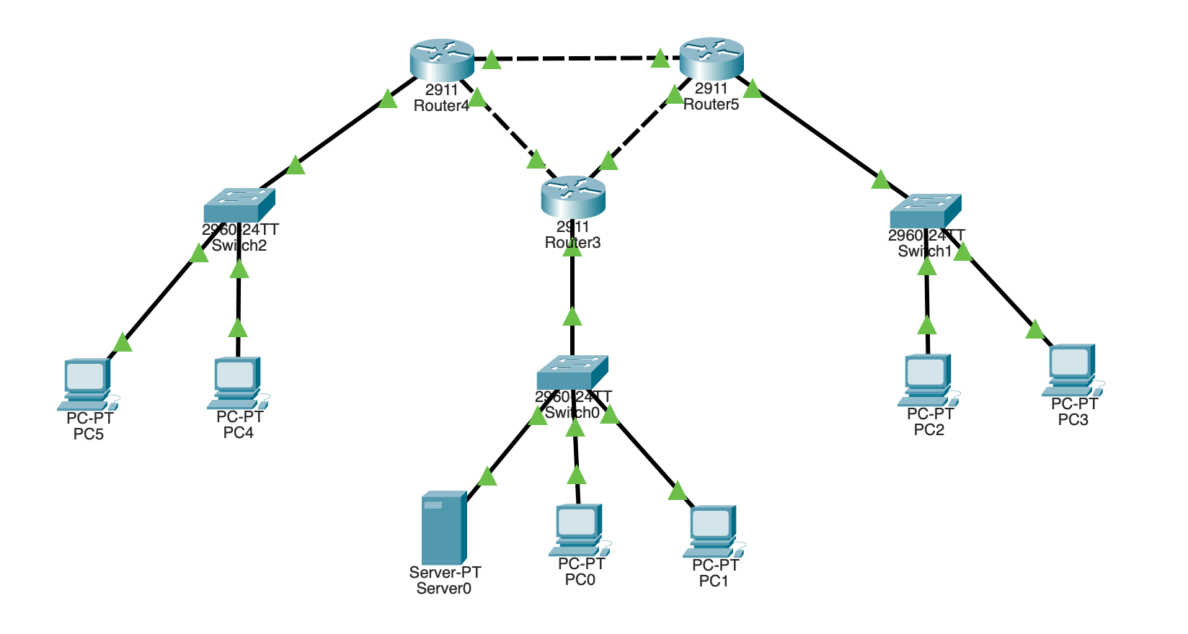

All IP addresses have been configured using DHCP from the server via RIP dynamic routing.

**

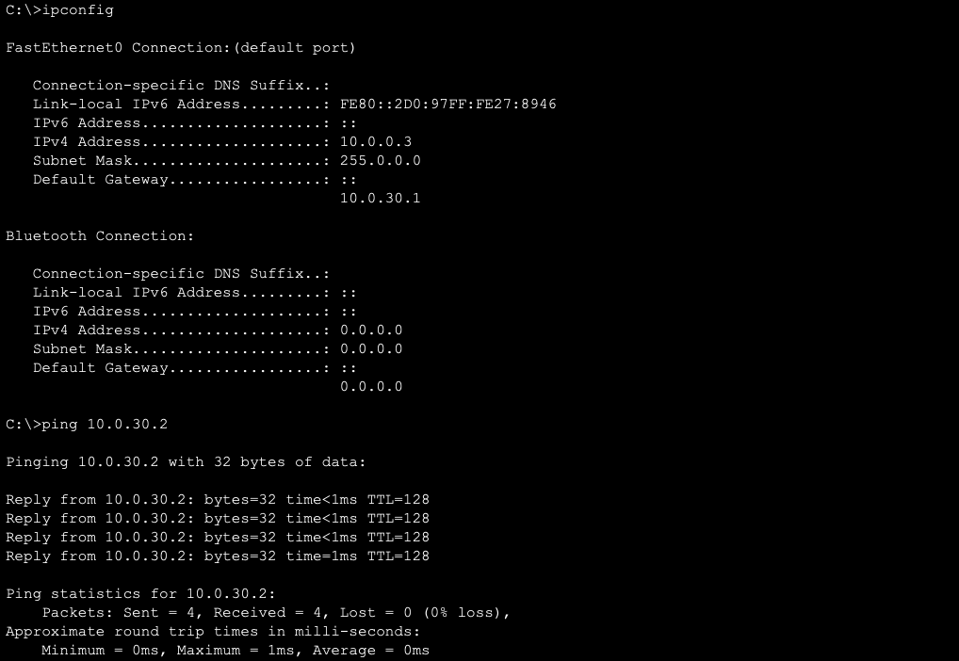

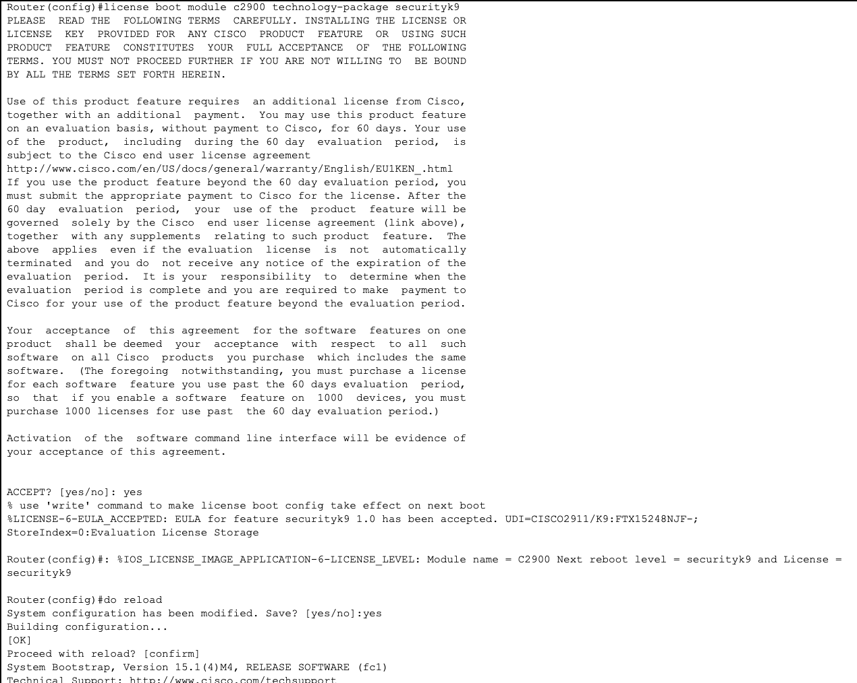

**After IPS Configuration**

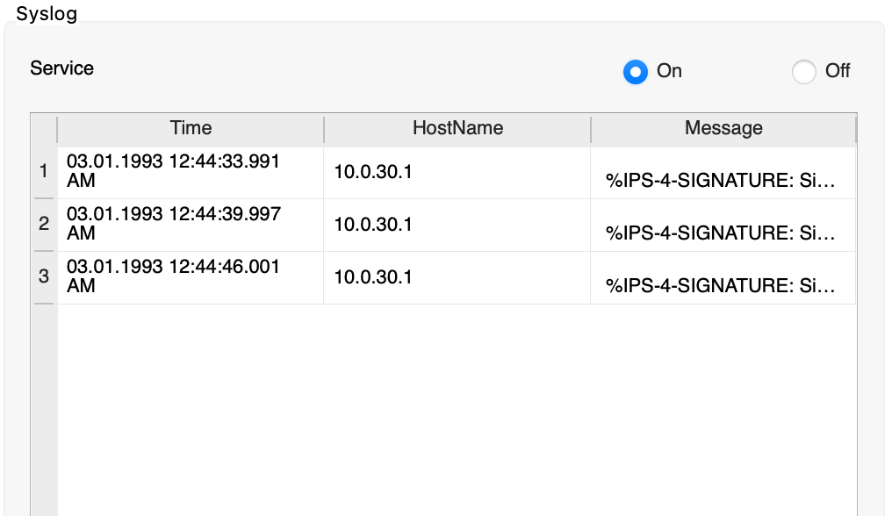

**Result**

IPS intrusion detection has been enabled in the router and logs out any detection to the server connected on the network.